Section A
For each question there are four possible answers, A, B, C, and D. Choose the one you consider correct and shade your choice on the answer sheet provided.

1 | Which of the following pairs of atoms are isotopes?
Atom 1 |  | Atom 2
Charge on  nucleus | Number of neutrons in nucleus | Charge on nucleus | Number of neutrons in nucleus
A 24+ | 30 | 26+ | 28
B 25+ | 30 | 26+ | 30
C 26+ | 31 | 26+ | 30
D 25+ | 30 | 26+ | 31

2 | An atom of carbon-12 has a mass calculated as 19.9 x 10⁻²⁴ g. The mass of one mole of scandium-45 is therefore approximately
 | A | 45 x 19.9 x 10⁻²⁴ g | C | 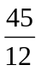 x 45.0 g
 | B | x 19.9 x 10⁻²⁴ g | D | 45.0 g

3 | 0.2 mol of ethanamide was boiled with 500 cm³ of 1.0 mol dm⁻³ sodium hydroxide until all the ammonia was expelled. The volume of 1.0 mol dm⁻³ hydrochloric acid needed to neutralise the cooled solution was
 | A | 200 cm³ | B | 300 cm³ | C | 400 cm³ | D | 500 cm³

4 | Samples of F₂ and Xe gases are mixed in a container of fixed volume. The initial pressures of F₂ and Xe are 8 atm and 1.7 atm respectively. When all the Xe gas has reacted forming only one solid compound, the pressure of the unreacted F₂ gas is 4.6 atm. The temperature remains constant.  What is the formula of the compound?
 | A | XeF | B | XeF₃ | C | XeF₄ | D | XeF₆
5 | Which one of the compounds is ionic and contains both sigma and pi bonds?
 | A | Fe(OH)₃ | B | HClO | C | H₂S | D | NaCN

6 | The Voyager 2 probe has shown that the surface of Triton, a moon of the planet Neptune, contains solid methane which flows rapidly.  Which statement best explains the mobility of solid methane?
 | A | Methane molecules contain strong C-H bonds.
 | B | Solid methane has a metallic structure.
 | C | The intermolecular forces between methane molecules are weak.
 | D | Triton has a low atmospheric pressure.

7 | The standard enthalpy changes of formation of carbon dioxide and water are −394 kJ mol⁻¹ and −286 kJ mol⁻¹ respectively.  If the standard enthalpy change of combustion of propyn, C₃H₄, is −1938 kJ mol⁻¹, what is its standard enthalpy change of formation?
 | A | +184 kJ mol⁻¹ | C | +284 kJ mol⁻¹
 | B | −184 kJ mol⁻¹ | D | −284 kJ mol⁻¹

8 | H₂PO₄⁻ + HBO₃ ²⁻ HPO₄²⁻ + H₂BO₃⁻  The equilibrium constant for the above reaction represented by the equation is greater than 1.0.  Which of the following gives the correct relative strength of the acids and bases in the reaction?
 | A | H₂PO₄⁻ > H₂BO₃⁻ and HBO₃²⁻ > HPO₄²⁻
 | B | H₂BO₃⁻ > H₂PO₄⁻ and HBO₃²⁻ > HPO₄²⁻
 | C | H₂PO₄⁻ > H₂BO₃⁻ and HPO₄²⁻ > HBO₃²⁻
 | D | H₂BO₃⁻ > H₂PO₄⁻ and HPO₄²⁻ > HBO₃²⁻

9 | The pH range and color changes for two acid-base indicators are given below.  Indicator pH range  X violet 3.0 – 5.0 red  Y yellow 5.6 – 7.6 blue  A solution in which X is red and Y is yellow is
 | A | 0.1 mol dm⁻³ HCl
 | B | 0.1 mol dm⁻³ CH₃COOH (K_{a} = 1.8 x 10⁻⁵ mol dm⁻³)
 | C | 0.1 mol dm⁻³ HX (K_{a} = 2.5 x 10⁻¹⁰ mol dm⁻³)
 | D | 0.1 mol dm⁻³ NH₃ (K_{b} = 1.8 x 10⁻⁵ mol dm⁻³)

10 | The graphs show the changes in concentration for a reaction that goes to completion.  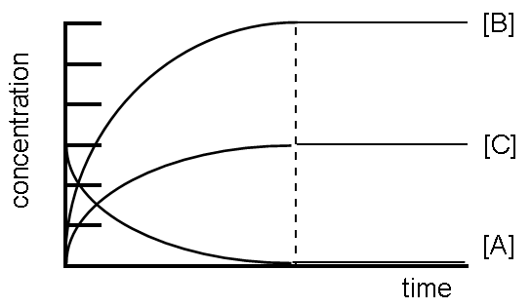  The equation for the reaction is
 | A | A → 2B + C
 | B | A + C → 2B
 | C | A → B + 2C
 | D | A + B → C

11 | The diagram below represents the reaction profile of a typical reversible reaction.  reactants products  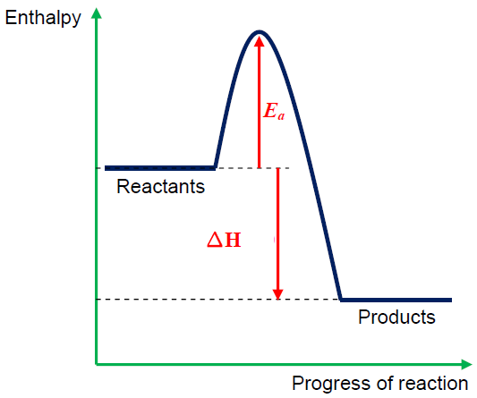  Which statement about the equilibrium is incorrect?
 | A | The equilibrium constant, K_{c}, will be larger at lower temperature.
 | B | Both the rate constants, k₁ and k₋₁ will increase by heating the equilibrium mixture.
 | C | Both the rate constants, k₁ and k₋₁ will increase by introducing a catalyst.
 | D | Both the rate constants, k₁ and k₋₁ will increase by increasing the concentration of the reactants.

12 | Use of the Data Booklet is relevant to this question.  MnO_{2(s)} + 4H⁺_{(aq)} + 2e à Mn^{2+(aq)} + 2H₂O_{(l)}  Cl_{2(g)} + 2e à 2Cl⁻_{(g)}  It may be predicted that chloride ions will not be oxidised by solid MnO₂. However chlorine can be prepared by heating this oxide with concentrated hydrochloric acid.  Which statement explains the given observations?
 | A | The standard redox potential applies only under specified conditions of concentrations and temperature.
 | B | The standard redox potential applies only if one mole of MnO₂ is used.
 | C | The MnO₂ needs to be in an alkaline solution.
 | D | Concentrated hydrochloric acid contains almost no chloride ions.

13 | Consider the electrochemical cell shown.  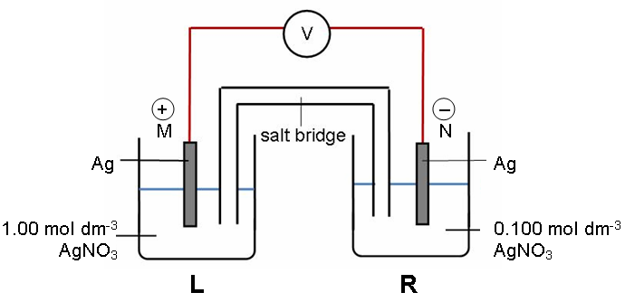  Which statement is correct about this given cell?
 | A | The E_{cell} value will decrease when solid NaCl is added to half cell L.
 | B | Electrons flow from half cell L to half cell R.
 | C | M is the anode and N is the cathode.
 | D | E_{cell} value remains the same when NH_{3(g)} is added to half cell R.

14 | Mercury is eliminated from the body in a first order reaction with a half-life of 60 days. If a mouse eats a piece of tuna fish contaminated with 1 mg of mercury, how much of this mercury will remain in the body after 180 days?
 | A | 0 mg | B | 0.125 mg | C | 0.25 mg | D | 0.50 mg

15 | Step 1: Ce⁴⁺ + Mn²⁺ à Ce³⁺ + Mn³⁺  Step 2: Ce⁴⁺ + Mn³⁺ à Ce³⁺ + Mn⁴⁺  Step3: Mn⁴⁺ + Tl⁺ à Tl³⁺ + Mn²⁺  The proposed steps for the catalysed reaction between Ce⁴⁺ and Tl⁺ are represented above.  The products of the overall catalysed reaction are
 | A | Ce⁴⁺ and Tl⁺ | C | Ce³⁺ and Mn³⁺
 | B | Ce³⁺ and Tl³⁺ | D | Ce³⁺ and Mn⁴⁺

16 | The standard enthalpy change of precipitation of AgI(s) is endothermic.  Ag(NH₃)₂⁺_{(aq)} + I⁻_{(aq)} à AgI_{(s)} + 2NH_{3(aq)}  What are the correct signs of ∆S^{Ɵ} and ∆G^{Ɵ} for this spontaneous reaction?
∆S | ∆G
- | -
+ | +
+ | -
- | +

 | A
 | B
 | C
 | D

17 | 3 elements A, B and C have successive atomic numbers, each increasing by one proton in the order given. A forms the ion A⁻ and C forms the ion C⁺.  Which statement concerning A, B and C and their ions is incorrect?
 | A | Atoms of element B react with either element A or C.
 | B | Element C forms a compound with chlorine with the formula CCl.
 | C | Element A reacts with element C to form a compound with the formula AC.
 | D | The ions A⁻ and C⁺ are isoelectronic with atoms of element B.

18 | Although the second ionisation energy of Mg is about double that of its first ionisation energy, the Mg⁺_{(aq)} ion does not exist in aqueous solution.  Which statement explains this observation?
 | A | The hydration of the doubly charged cation gives sufficient energy to overcome the second ionisation energy.
 | B | The following reaction readily occurs: 2Mg⁺_{(g)} → Mg_{(s)} + Mg²⁺_{(aq).}
 | C | Mg²⁺_{(g)} has a higher energy content than that of Mg⁺_{(g)}.
 | D | Hydrogen bonding formation in aqueous solution stabilises the doubly charged cation.

19 | Which statement is correct about the hydrogen halides HF, HCl, HBr, HI?
 | A | All form hydrogen bonds with water in aqueous solution.
 | B | Their boiling points increase progressively from HF to HI.
 | C | An aqueous solution of HF is the strongest acid.
 | D | HF cannot be oxidised to fluorine by any of the other halogens.

20 | Which of the compounds has a transition metal with a zero oxidation state?
 | A | Ni(CO)₄ | C | [Co(NH₃)₆]Cl₃
 | B | [Fe(H₂O)₆]SO₄ | D | Fe(H₂O)₃(OH)₃

21 | The molecule which is not chiral is
 | A | 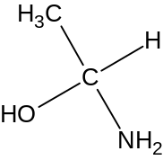 | C | 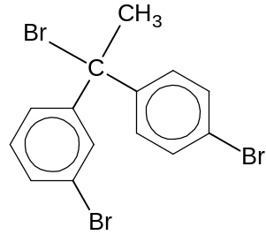
 | B | 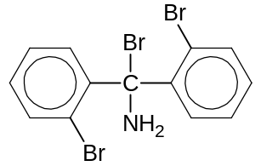 | D | 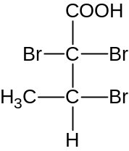

22 | The structural formula of an organic compound is as shown.  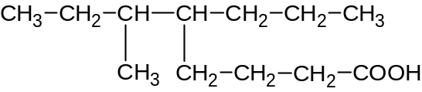  The IUPAC name for this compound is
 | A | 3-methyl-4-butyloctanoic acid
 | B | 3-methyl-4-propyloctanoic acid
 | C | 4-propyl-5-methyloctanoic acid
 | D | 6-methyl-5-propyloctanoic acid

23 | Consider the solubilities of the following compounds in water.
 | W | 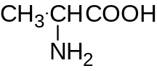 | Y | CH₃CH(OH)CH₃
 | X | CH₃CH₂OCH₃ | Z | CH₃CH(OH)CH₂OH
 | The order of increasing solubility of the compounds is
 | A | Z W Y X
 | B | X Y Z W
 | C | Y Z X W
 | D | X W Y Z

24 | The compound least likely to be formed when gaseous ethene is bubbled into a mixture of aqueous bromine and aqueous sodium chloride is
 | A | CH₂BrCH₂Br
 | B | CH₂BrCH₂OH
 | C | CH₂BrCH₂Cl
 | D | CH₂ClCH₂Cl

25 | Cl₂ was passed into methylbenzene under reflux. Which of the following mechanistic step might occur?
 | A | 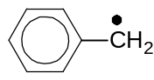 | + | HCl | → | 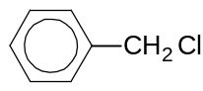 | + | H•
 | B | 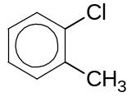 |  |  | → | 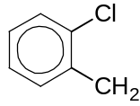 | + | H⁺
 | C |  | + | Cl• | → | 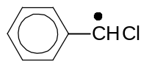 | + | HCl
 | D | 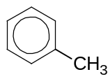 | + | Cl⁺ | → | 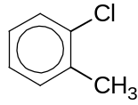

26 | One method of determining the protein content of a food is to determine its nitrogen content. This is done by first converting the nitrogen to ammonium sulfate and then to ammonia.  Calculate the mass in grams of ammonia formed if all the nitrogen in 1 mole of arginine is converted into ammonia.  Formula of arginine:  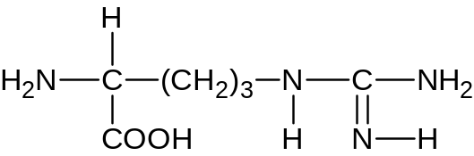
 | A | 34 g | B | 68 g | C | 132 g | D | 264 g

27 | A dibromoalkane CH₃CH₂CHBrCHBrCH₂CH₃ was treated with excess alcoholic potassium hydroxide. The main product would be
 | A | CH₃CH₂CH(OH)CH(OH)CH₂CH₃
 | B | CH₃CH₂CH₂O⁻K⁺
 | C | CH₃CH=CH-CH=CHCH₃
 | D | CH₃CH₂CH=CHCH₂CH₃

28 | Bradosol is a compound used for the relief of sore throats. It is produced in the following reaction.
 | 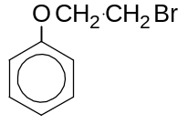 |  | + | 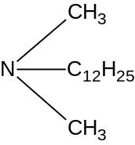 | → | 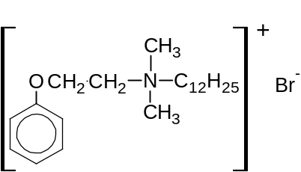
 | X |  |  | Y |  | Bradosol
 | The role of compound Y in this reaction is
 | A | an acid
 | B | a nucleophile
 | C | an electrophile
 | D | a reducing agent

29 | Which reaction is not typical of carbonyl compounds?
 | A | 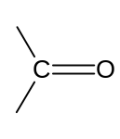 | + | H₂ | → | 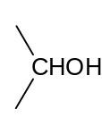
 | B |  | + | H₂N–OH | Pt  → | 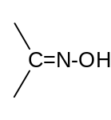 | + H₂O
 | C |  | + | CH₃–Br | → | 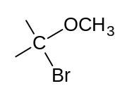
 | D |  | + | HCN | OH⁻  → | 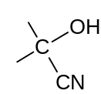

30 | A compound R was used for two experiments and the results as shown below.  Which of the following compounds could be R?
  No. | Experiment | Results
  I | stirred with cold NaOH_{(aq)} | 1 chlorine atom was removed per molecule of R
  II | stirred with hot NaOH_{(aq)} | 2 chlorine atoms were removed per molecule of R.
 | A | 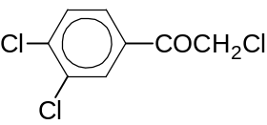 | C | 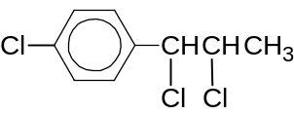
 | B | 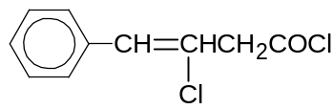 | D | 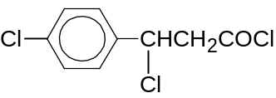

Section B

For each of the questions in this section, one or more of the three numbered statements 1 to 3 may be correct.
Decide whether each of the statements is or is not correct (you may find it helpful to pick a tick against the statements that you consider to be correct).
The responses A to D should be selected on the basis of

A | B | C | D
1, 2 and 3 are correct | 1 and 2 only are correct | 2 and 3 only are correct | 1 only is correct

No other combination of statements is used as a correct response.

31 | Which statements about the molecules OCl₂, NCl₃ and CCl₄ are correct?
 | 1 | The Cl-O-Cl bond angle is smaller than Cl-N-Cl bond angle.
 | 2 | The bond length decreases in the order O-Cl, N-Cl and C-Cl.
 | 3 | The shapes of the molecules are linear, trigonal planar and tetrahedral respectively.

32 | Which of the reactions involve disproportionation?
 | 1 | 2C₂H₅•_{(g)} → C₂H_{6(g)} + C₂H_{4(g)}
 | 2 | 2H₂O_{2(aq)} → 2H₂O_{(l)} + O_{2(g)}
 | 3 | 3MnO₄²⁻_{(aq)} + 4H⁺_{(aq)} → 2MnO₄⁻_{(aq)} + MnO_{2(s)} + 2H₂O_{(l)}

33 | A closed vessel contains 11 g of CO₂ and 8 g of O₂.  Which statements concerning the behaviour of these 2 gases are correct?
 | 1 | The average molecular velocity of CO₂ is greater than that of O₂.
 | 2 | The average molecular kinetic energy of CO₂ and O₂ is the same.
 | 3 | Both CO₂ and O₂ have the same partial pressure.

34 | H₂O auto-ionises as shown by the equation below.  2H₂O H₃O⁺ + OH⁻  The ionic product of water is given by the expression Kw = [H₃O⁺][OH⁻] which increases with increasing temperature.  What conclusions can be drawn about this reaction?
 | 1 | The pH of hot water is smaller than that of cold water.
 | 2 | The electrical conductivity of hot water is greater than that of cold water.
 | 3 | The dissociation of water is exothermic.

35 | Use of the Data Booklet is relevant to this question.  Which statements about Na⁺, Mg²⁺ and Al³⁺ ions are correct?
 | 1 | NaCl has no covalent character as Na⁺ is an ion with low charge density.
 | 2 | Al³⁺ forms Al(H₂O)₆³⁺ readily but not Na⁺.
 | 3 | Al³⁺ has the most exothermic enthalpy change of hydration.

36 | Use of the Data Booklet is relevant to this question.  The following pairs of species of d-block elements with the same electronic configuration are
 | 1 | VO²⁺, TiCl₃
 | 2 | MnO₄ ⁻, Cr₂O₇²⁻
 | 3 | Cr, Co(H₂O)₆³⁺

37 | Solid enantiomers (optical isomers) possess the same
 | 1 | rotation of polarised light
 | 2 | melting point
 | 3 | density

38 | A compound K reacted with phenylhydrazine to yield another compound with the structure shown.  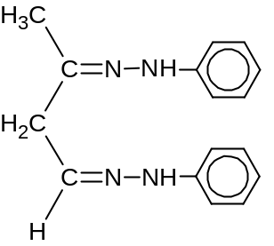  Which pairs of reagents would react with K when added to K separately?
 | 1 | Lithium aluminium hydride in dry ether and acidified K₂Cr₂O₇
 | 2 | Lithium aluminium hydride in dry ether and sodium
 | 3 | Lithium aluminium hydride in dry ether and alcoholic KCN

39 | Benzene reacts with Br₂ in the presence of FeBr₃, forming bromobenzene via electrophilic substitution. The elementary steps of the reactions are:
 |  | FeBr₃ + Br₂ → FeBr₄⁻ + Br⁺
 |  | 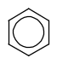 | + | Br⁺ | → | 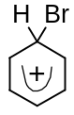
 |  |  |  | → | 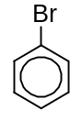 |  | + |  | H⁺
 |  | H⁺ + FeBr₄⁻ → FeBr₃ + HBr
 | Which conclusions can be drawn about the mechanism?
 | 1 | The reaction level diagram is |  |  |  |  |  |  |  | 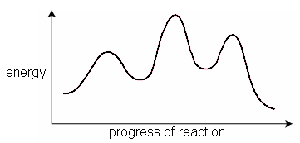
 | 2 | The transfer of electron is |  |  |  |  |  | 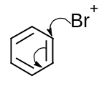
 | 3 | The intermediate for the reaction is planar.

40 | In an artificial hip joint, the poly(ethene) cup for this joint is attached to the pelvic girdle by bone cement. The formation of the cement is highly exothermic and involves polymerisation of the structure shown below.  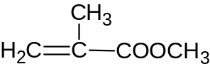  Which statements about the reactions of this structure are correct?
 | 1 | It undergoes electrophilic addition.
 | 2 | It is readily hydrolysed in dilute H₂SO₄ and aqueous NaOH.
 | 3 | Its oxidised products are CH₃OH and CH₃COCOOH when subjected to acidified K₂Cr₂O₇.

